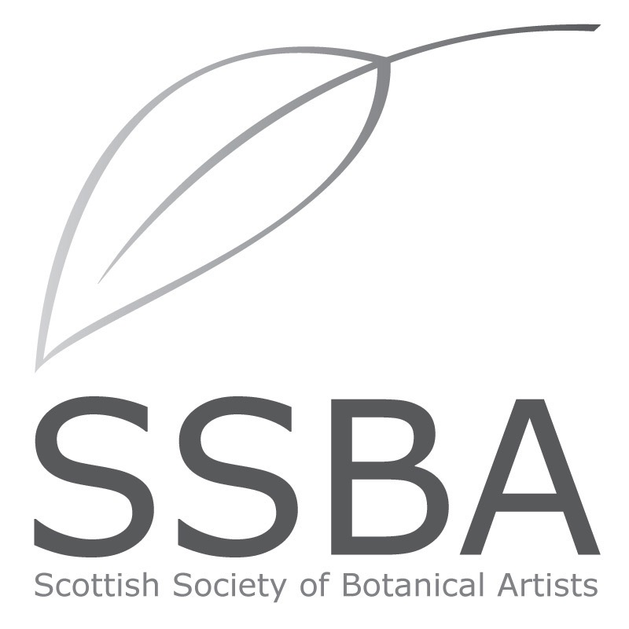

Scottish Society of Botanical Artists
The Scottish Society of Botanical Artists recognises the contribution of the Scottish plant hunters and botanical artists of the past and present, and strives to nurture the ongoing art and science of botanical art, through conservation, botany, horticulture and art.
We aim to
• Raise the profile and promote botanical art in Scotland
• Provide a forum to share and disseminate knowledge and expertise in all aspects of botanical art
• Encourage a high standard of botanical artistic achievement
• Provide a platform for the exhibition of botanical art in Scotland
Membership
There are three categories of Membership, with fees payable annually in January.
Full Membership: Open to all Botanical artists, wishing to exhibit work in main exhibitions, and participate in events. Full voting rights.
Student Membership: Open to those students studying an accredited course in Art, or Botanical Art that leads to a qualification. Students can exhibit and participate in events. Full voting rights.
Friend: Open to anyone wishing to support the work of the Society. Allows free entry to view exhibitions, invitations to previews and applications to events. This category does not allow exhibition entries or voting rights.
All members may apply to attend events and for places on courses.
Annual subscription due by the end of January each year prior to AGM:
Full membership: £50 Student Membership: £20 Friend: £20
Please post your application form to:
Mrs. A Carlaw, SSBA Treasurer
32 Abden Avenue,
Kinghorn, Fife, KY3 9TE

MEMBERSHIP APPLICATION/RENEWAL 2018
Please print your details below:
Title: _____________________
First Name: ____________________ Surname: __________________
Address: ______________________________
______________________________
Post code: ____________________________
Home telephone number:
Mobile number:
Email address:
I DO/DO NOT authorise my telephone number and email address to be circulated among other members only, for the purpose of sharing transport to meetings, courses and exhibitions.
Membership requested: please tick category below
Full £50 Student £20 Friend £20
Additional donations are most welcome: £
Date of Joining/Renewal: ___________________
I enclose my cheque for £ ____ made payable to the SSBA
OR by bank transfer to Sort code 80-22-60 Account no. 13727960
Please put your name and MEMBERSHIP SUBS as reference.
Signature:
PLEASE POST or email TO
Mrs. A Carlaw, SSBA Treasurer,
32 Abden Avenue, Kinghorn
Fife KY3 9TE
annecarlaw6@gmail.com

