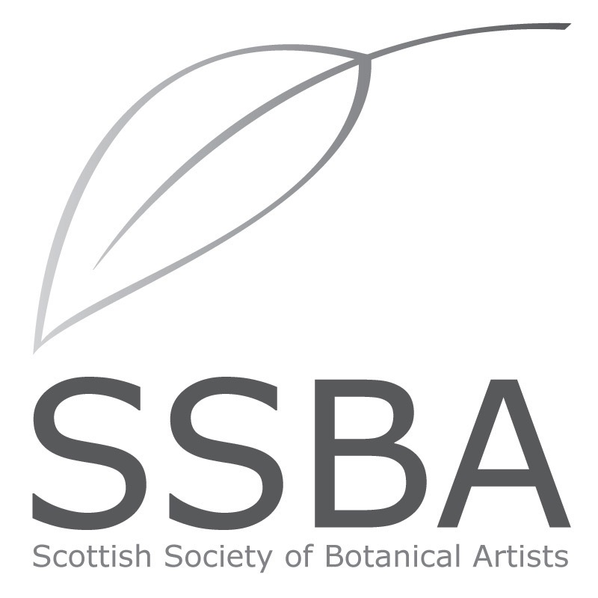

**MEMBERSHIP APPLICATION/RENEWAL 2020**

Please print your details below:

**Title**: _____________________

**First Name:** ____________________ **Surname:** __________________

**Address:** ______________________________

______________________________

**Post code:** ____________________________

**Home telephone number: Mobile number:**

**Email address:**

**Membership requested:** please tick category below ✅

Full member £50 Student* £20 Friend £20

[*enrolled on a certificated botanical art course]

**I enclose my cheque for** £ ____ made **payable to the SSBA**

**OR** by bank transfer to **Sort code 80-22-60. Account no. 13727960**

Please put your name and MEMBERSUB as reference.

Additional donations are most welcome: £

**Signature: ___________ Date of Joining/Renewal:** __________

* PLEASE POST or email TO SSBA Treasurer:

Dr. Kate Braithwaite, 9 Manse Brae, Dalserf, Larkhall, Lanarkshire, ML9 3BN

[katebraithwaite@btinternet.com](mailto:katebraithwaite@btinternet.com)

Membership is renewed annually in January.

**I DO / DO NOT** authorise my email address to be used for email correspondence from the SSBA and shared with other members only to share information about events, transport to meetings, courses and exhibitions.