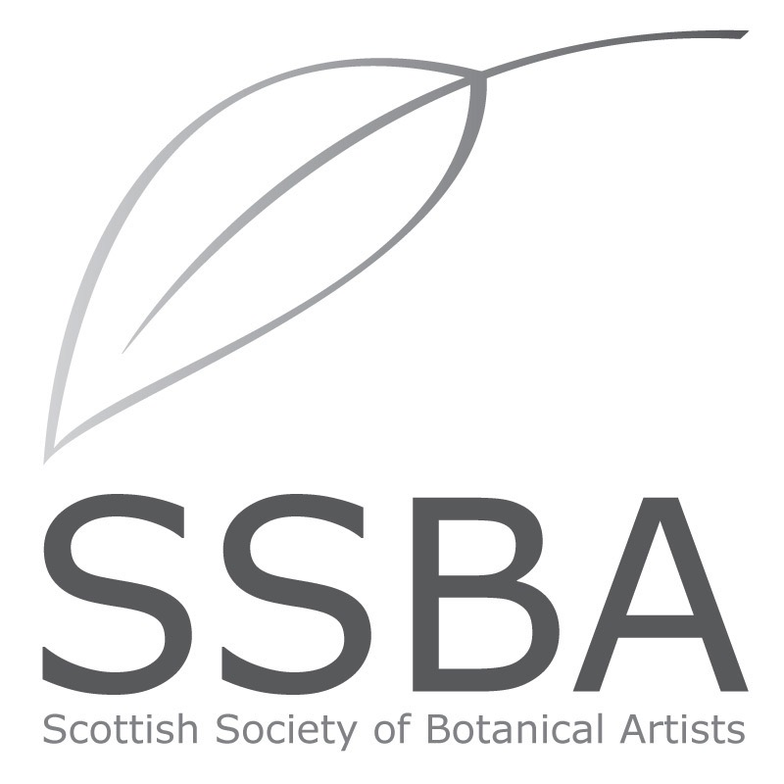

MEMBERSHIP APPLICATION / RENEWAL 2020

Please print your details below:
Title: ____________________
First Name: ____________________ Surname: ____________________
Address: _______________________________
_______________________________
Post code: _______________________________
Home telephone number: ___________________ Mobile number: _________________
Email address: ______________________________________________

Membership requested: please tick category below ✅
Full member £50 _____ Student* £20 _____ Friend £20 _____
[*enrolled on a certificated botanical art course]
Payment methods:
- I enclose my cheque for £ ____ made payable to the SSBA
- Bank transfer to sort code 80-22-60, account no. 13727960
- PayPal (online via website)

Please put your name and MEMBERSUB as reference.

Additional donations are most welcome: £_____

Signature: ____________________ Date of Joining/Renewal: ______________

Please post or email to SSBA Treasurer: Dr. Kate Braithwaite, 9 Manse Brae, Dalserf, Larkhall, Lanarkshire, ML9 3BN or katebraithwaite@btinternet.com

Membership is renewed annually in January.

I DO / DO NOT authorise my email address to be used for email correspondence from the SSBA and shared with other members only to share information about events, transport to meetings, courses and exhibitions.

