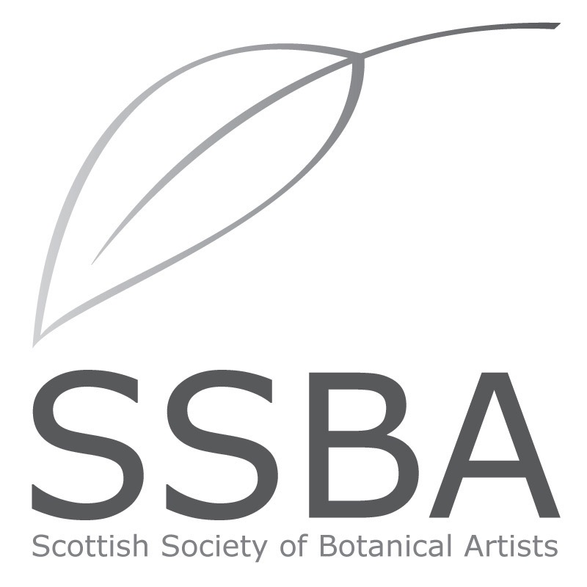

MEMBERSHIP APPLICATION/RENEWAL 2022
Membership is renewed annually before January 31st.

Please print your details below:
Title: _____________________
First Name: Surname:
Address:

Post code:
Home telephone number: Mobile number:
Email address:
Membership requested: please tick category below ✅
Full member £50 Student* £20 Friend £20
[*enrolled on a certificated botanical art course]
Payment methods:
- I enclose my cheque for £ ____ made payable to the SSBA
- Bank transfer to sort code 80-22-60, account no. 13727960
- PayPal (online via website)

Please put your surname and MEMBERSUB as reference.

Additional donations are most welcome: £___. Please use Gift Aid form available from www.thessba.org
Signature: ______________________ Date of Joining/Renewal: _____________
PLEASE POST or email TO SSBA Treasurer: treasurer@thessba.org
Dr. Kate Braithwaite, 9 Manse Brae, Dalserf, Larkhall, Lanarkshire, ML9 3BN

I DO/DO NOT authorise my email address to be used for email correspondence from the SSBA.
Please tick ✅ if you have any of the following: -

A Botanical Illustration Certificate or Diploma?

OR Have you attended Classes or Workshops in Botanical Art

