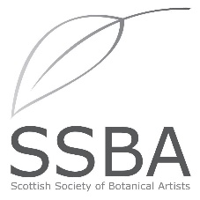
MEMBERSHIP APPLICATION/RENEWAL FORM 2024
To be renewed annually before 31st January.

Title |  | First Name |  | Surname
Address
Contact number |  |  | E-mail Address

Membership Type (please tick)
Full Member £50 |  | Student* £20 |  | Friend £20
*enrolled on a certified botanical art course
Application forms can be e-mailed to treasurer@thessba.org
Payment methods –
- By cheque made payable to SSBA and posted to Valerie Gordon, 27 Blinkbonny Road, Ravelston, Edinburgh, EH4 3HY with application form.
- By Bank Transfer to Business Account, The Scottish Society of Botanical Artists
Sort Code 80-22-60, Account Number 13727960. Use your surname and SUB as reference
- By PayPal via the online website (this does incur charges to the SSBA)
Additional donations are most welcome. I include donation of £__
GIFT AID: I would like the SSBA to reclaim the tax on any eligible donations or membership subscriptions that I have already made in the last four years or will make until further notice. I am a UK taxpayer and understand that if I pay less Income Tax and/or Capital Gains Tax than the amount of the Gift Aid claimed on all my donations and membership subscriptions in that tax year, it is my responsibility to pay the difference.
Yes |  | No

Yes |  | No
I consent to my personal data being used by the SSBA to contact me regarding SSBA activities and events

I have a certificate in Botanical Illustration |  | I have a Diploma in Botanical Illustration
I have attended classes in Botanical Illustration |  | I have attended workshops in Botanical Illustration

Signature |  | Date

