Workshop with Victoria Braithwaite

Detail at scale – choosing and enlarging subjects for visual impact

Where: The McHattie Room, Saughton Park, Edinburgh
When: Saturday 31st May and Sunday 1st June 2025

Cost: Numbers are limited to 10 and the cost of the workshop is £150.00 for SSBA members and £170.00 for non-members. This includes tea or coffee each day. There is free parking at the venue.

A small list of suggested materials:

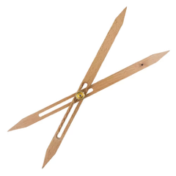

- A set of dividers, such as these: https://www.artsupplies.co.uk/p/scale-dividers?srsltid=AfmBOorRTHaIkJRjHqKFW-RBYKBqqZv2AEpB_Jqo-tLUJPGtEysZmQHl
- Brushes (round watercolour with good points) - size 1, plus a size 6 or 8 or larger if you have one
- Pencil and rubber
- Sketchbook or sketch paper
- Phone or iPad (for photography and zooming in on details)
- Watercolour paper (in block, book or loose sheet, preferably 100% cotton hot pressed)
- Your usual paints
- Kitchen roll
- Water container

On receipt of your application form we will confirm your booking and provide payment details

Please return the BOOKING FORM on next page to contact@thessba.org

Workshop with Victoria Braithwaite

BOOKING FORM

Detail at scale – choosing and enlarging subjects for visual impact

Where: The McHattie Room, Saughton Park, Edinburgh
When: Saturday 31st May and Sunday 1st June 2025

The Cost is £150.00 for SSBA members and £170.00 for non-members. This includes tea or coffee each day.

NAME: in block capitals please

SURNAME FIRST NAME

__________________ ______________

email address: _________________________

phone number: _________________________

You will receive an email confirming your place and providing payment details

Please pay once your place is confirmed

Please complete this form, scan or photograph it and return to

contact@thessba.org

Any problems with the form please email details to contact@thessba.org

