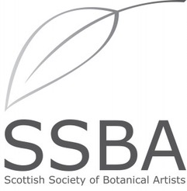

BOOKING FORM
Fundamentals of Botanical Art with Lyn Campbell

Where: The McHattie Room, Saughton Park, 60A Ford's Rd, Edinburgh EH11 3HH

Sunday 22nd February Saturday 7th March
Sunday 22nd March Saturday 11th April
All 10am to 3pm

YOUR NAME: in block capitals please

SURNAME FIRST NAME

__________________ ______________

email address: _________________________

phone number: _________________________

Please let us know by ticking below if; √

You have used watercolours before

If you have been to any botanical art workshops

I am a member of the SSBA

You will receive an email confirming your place and providing payment details.

Payment will be requested and bank details provided once your place is confirmed.

A list of materials useful for this course will be sent to you following payment.

Please complete this form, scan or photograph it and return to:-

secretary@thessba.org

Thank you

https://thessba.org/become-a-member/

